




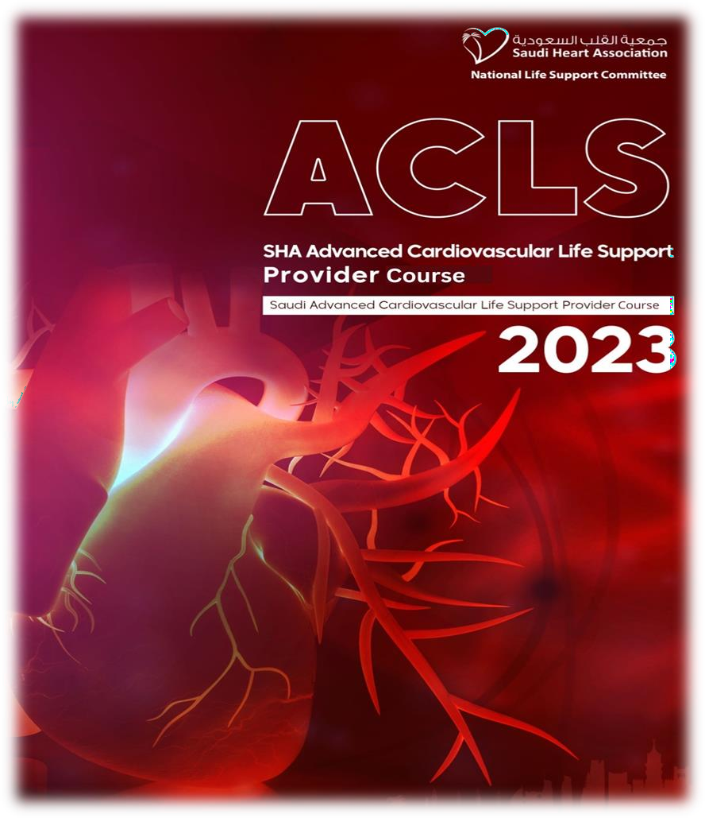

KINGDOM OF SAUDI ARABIA MINISTRY OF HEALTH
RIYADH FIRST HEALTH CLUSTER- ALKHARJ ZONE
KING KHALID HOSPITAL AND PRINCE SULTAN CENTER FOR HEALTH SERVICES, AL-KHARJ

Academic &Training Affairs Department


ACLS COURSES
The trainee must enter the Saudi Heart Association website
https://shacpr.org.sa/Home

To activate your account, log into your Saudi Heart Association account, then click on my wallet, choose the purchase balance icon, then choose the appropriate method for you to pay 50 riyals, for complete registration contact with ATA. Then register on the link to attend the course

https://forms.gle/S6BDpxkaD9BFKwj36

After registering and choosing the appropriate dates through the Academic Affairs Department, the ACLS, Pretest is done and the result is printed and delivered to the trainer when the course is implemented




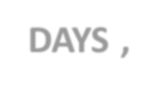
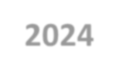

Medical Lecture Room
MONTHALY
2DAYS ,2025
09:00AM – 2:00PM

Email: ruh-kkhal-train@moh.gov.sa Tel: 0115444444 Ext: 3373 –3363 -3410 0530823115 8:00AM -3:00PM موسى رباب .ا

