​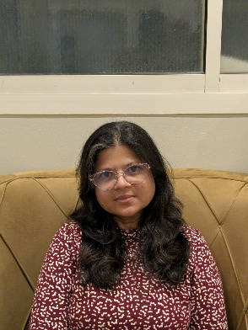
Himali Santosh Kesarkar
​Contact Information
​Email: himalikesarkar1@gmail.com
​Indian Mobile: +91 98334 95242
​Saudi Mobile: +96650303 7695
​India Address: 377/B, Shreepad Co-op Hsg Society, Flat No. 2, Ground Floor, V.P. Road, Mumbai- 400 004
​Nationality: Indian | Marital Status: Married
​Professional Summary
​Results-driven Human Resources and Administration professional with extensive experience in HR Management, team leadership, and hospital administration. Proven ability to implement policies, manage staff and resources, and optimize operational efficiency. Strong background in leadership, time management, and a commitment to professional development.
​🏥 Professional Experience
​HR Head & Administrator | Moralwar Child Care Hospital & Vashi Hospital and ICU
(2019 – 2025)
​Led comprehensive Human Resources management and administrative functions across the hospital.
​Successfully managed hospital operations, staff scheduling, and resource allocation to ensure smooth functioning.
​Developed and implemented new HR policies and standard operating procedures.
​Applied strong leadership and team management skills to oversee diverse teams.
​Clerical Staff | Mercantile Marine Department (2006)
​Managed crucial records and documentation efficiently.
​Performed essential administrative tasks, supporting department operations.
​Drawing Teacher | Hindi Vidya Bhavan School, Mumbai
(2008 – 2013)
​Utilized teaching and time management skills.
​Developed and executed structured curriculum and lesson plans.
​Freelance Artist
(2006 – 2019)
​Managed business operations and client relationships. (Included to show entrepreneurial/business acumen)
​🛠️ Key Skills
​Human Resources Management
​Administration & Operations
​Leadership & Team Management
​Policy Implementation
​Time Management
​Documentation & Record Management
​Teaching/Training
​Information Technology (IT): Diploma in Information Technology, C-DAC
​🎓 Educational & Professional Qualifications
​PG Diploma in Therapeutic Intervention Skills for Psycho-Social Disorders (2013)
​Master of Visual Arts (MVA), SNDT University
​Master in Drawing and Painting, SNDT University
​Bachelor of Arts, Mumbai University (1995)
​Diploma in Information Technology, C-DAC
​Wou

