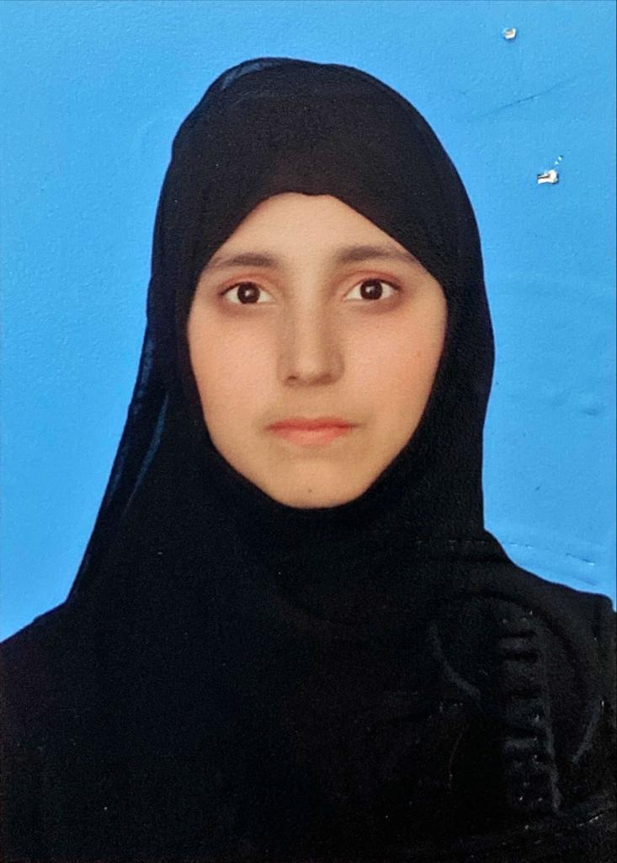
Dr. Huma Azam, BDS
Registered Dental Surgeon, Pakistan
Phone: +966-536990157
Email: humaazam1998@gmail.com
Location: Riyadh, Saudi Arabia
License Number: 72066-01-D (PAK)

Professional Summary
Dedicated and compassionate general dentist with over 2 years of clinical experience in restorative and preventive dentistry. Skilled in-patient care, cosmetic procedures, and dental radiography. Committed to providing high-quality oral healthcare and building strong patient relationships.

Key Skills
- Restorative Dentistry
- Oral Surgery
- Basic Life Support training
- Endodontics (Root Canal Treatment)
- Cosmetic Dentistry (Whitening, Veneers)
- Digital X-rays & Imaging
- Patient Communication & Education
- Infection Control & Sterilization
- Dental Software (e.g., Dentrix, Eaglesoft)
- Team Leadership & Staff Supervision

Education
Bachelor in Dental Surgery, Sharif Medical and Dental College – Lahore, Pakistan
January, 2017 – June, 2021

Languages
- English – Fluent
- Arabic – Basic conversational skills
- Urdu – Native

Professional Experience
Position: General Dentist
Hospital Name: Sharif City Hospital – Lahore, Pakistan
Tenure: June, 2021 – July, 2022
Key Responsibilities:
- Performed general dental procedures including fillings, crowns, and root canals.
- Practiced minor oral surgeries including third molar extra6ction, facial sutures, intraoral and extraoral sutures.
- Performed periodontal procedures including scaling, polishing and gum treatments.
- Diagnosed and treated oral diseases, managed emergency cases.
- Supervised dental assistants and ensured hygiene protocols were followed.
- Increased patient satisfaction by improving follow-up procedures.

Licensure & Certifications
- Pakistan Medical and Dental Council, Membership # 72066-01-D, Pakistan
- Certification in Basic Life Support (BLS) – 2022

Research & Publications
- Clinical Attachment Loss and Periodontal Health Status of Smokers Versus Non-Smokers: A Comparative Study. SJGU Journal, 2022

